**Experiment 8**

**Student Name:** Sahil Kaundal **UID:** 21BCS8197

**Branch:** BE CSE (Lateral Entry) **Section/Group:** 616/A

**Semester:** 5th **Date of Performance:** 04/11/2022

**Subject Name:** ML Lab **Subject Code:** 20CSP-317

1. **Aim/Overview of the practical:**

Implement K-means clustering algorithm (cluster some sample data set into disjoint clusters using K-means).

1. **Task To Be Done:**

Implement K-means clustering algorithm (cluster some sample data set into disjoint clusters using K-means).

**3. Apparatus / Simulator Used:**

1. Windows 7 or above.
2. Google Collab.

**K-Means:**

K-means is an unsupervised learning method for clustering data points. The algorithm iteratively divides data points into K clusters by minimizing the variance in each cluster.

**4. Program / Commands:**

#Sahil Kaundal

#21BCS8197

import matplotlib.pyplot as plt

x=[4, 5, 10, 4, 3, 11, 14, 6, 10, 12]

y=[23, 19, 24, 17, 16, 25, 24, 22, 21, 21]

plt.scatter(x, y)

plt.show()

from sklearn.cluster import KMeans

data=list(zip(x ,y))

inertias=[]

for i in range(1, 11):

  kmeans= KMeans(n_clusters=i)

  kmeans.fit(data)

  inertias.append(kmeans.inertia_)

plt.plot(range(1, 11), inertias, marker='o')

plt.title('Elbow method')

plt.xlabel('Number of clusters')

plt.ylabel('Inertia')

plt.show()

kmeans=KMeans(n_clusters=2)

kmeans.fit(data)

plt.scatter(x, y, c=kmeans.labels_)

plt.show()

1. **Result/Output/Writing Summary:**

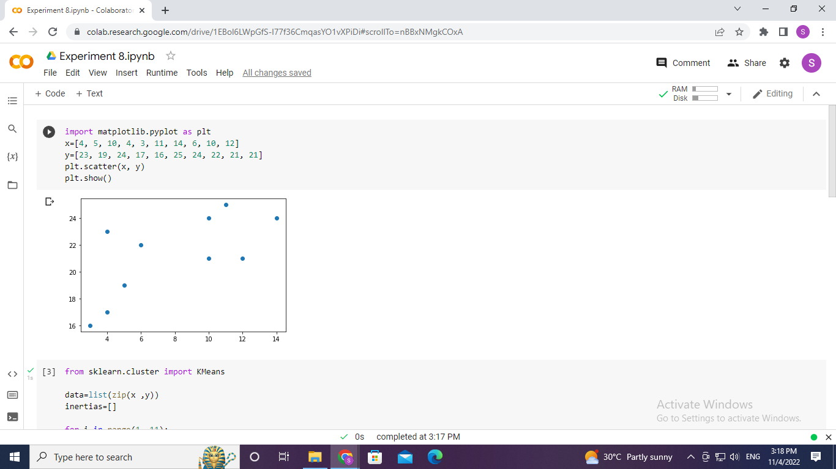

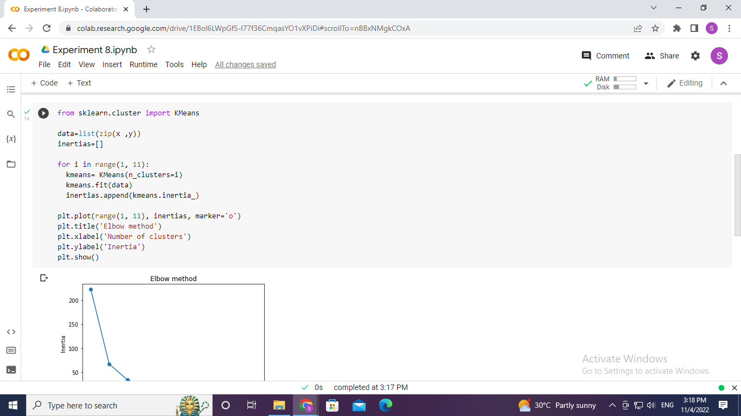

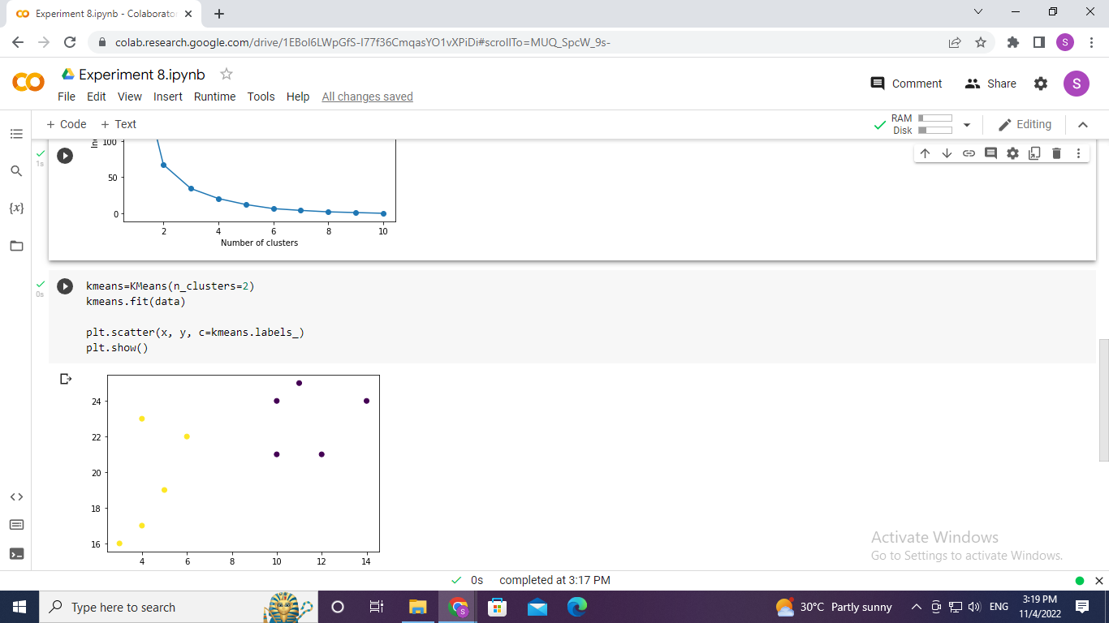

**Learning outcomes (What I have learnt):**

* Understood the concept of K-Mean.
* Learnt how to zip the two-array data in a single list.
* Learnt the Inertia calculation.
* Plot the graph for Inertia and Number of clusters.

**Evaluation Grid (To be created as per the SOP and Assessment guidelines by the faculty):**

|  |  |  |  |
| --- | --- | --- | --- |
| Sr. No. | Parameters | Marks Obtained | Maximum Marks |
| 1. |  |  |  |
| 2. |  |  |  |
| 3. |  |  |  |
|  |  |  |  |